**The UDP Bandmap**

Aki Yoshida JA1NLX

## 1. 0 GENERAL

Logger32 has a function to receive and display decoded callsigns with some additional information on the UDP Bandmap and send a reply message to JTDX or WSJT-X. JTDX or WSJT-X works as if the callsign is double-clicked on it's window when it receive reply message.. This data is distributed via UDP (User Datagram Protocol) approximately every 15 seconds (FT8 Mode) or 60 seconds (JT65, JT9 Mode etc) by WSJT-X/JTDX program. The reply message is sent via UDP.

When the QSO is logged in WSJT-X/JTDX then Logger32 will log this QSO via UDP and sends this QSO automatically as a DX Spot if you want. See the Setup Menu section in details.

**Note 1**: The UDP Bandmap and JTAlert program can not run at the same time.

**Note 2**: Use TCP or UDP for logging.

**Note 3:** 77 bit protocol which will be implemented in WSJT-X ver 2.0 is supported.

**Note 4:** WSJT-X only responds to one type of UDP Reply Message - "Answer this CQ call".

**Note 5:** Logger32 should log QSOs from JS8call and any other program that sends the WSJT-X formatted messages to the UDP port.  It is not necessary to have the UDP Bandmap open.

**Note 6:** UDP message processing to queue up to five QSO Logged messages is supported.  The QSOs should be logged about 5 seconds after they are received.  If the messages are from software other than WSJT/JTDX, no additional information (from the Logbook Entry Window, or the QSO mask is added.  Also, if the messages are not from WSJT/JTDX, it is not necessary to have the UDP BandMap open, but the UDP socket must be open.

**Note 7**: WSJT-X FT4 mode is supported.

## 2. WSJT-X/JTDX SETTINGS

### 2.1 Settings in WSJT-X program

Look for UDP Server group. You should leave the default value like this.

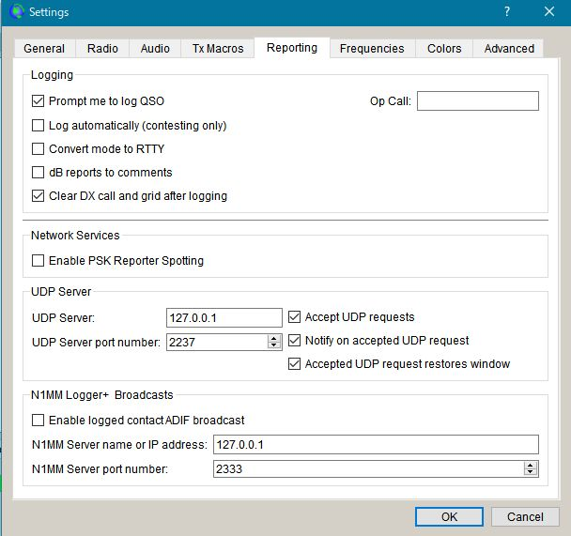

UBM_1

### 2.2 Settings in JTDX program

Look for UDP Server group. You should leave the default value like this.

Look for External logbook connection group. Uncheck "Enable data transfer to external log"

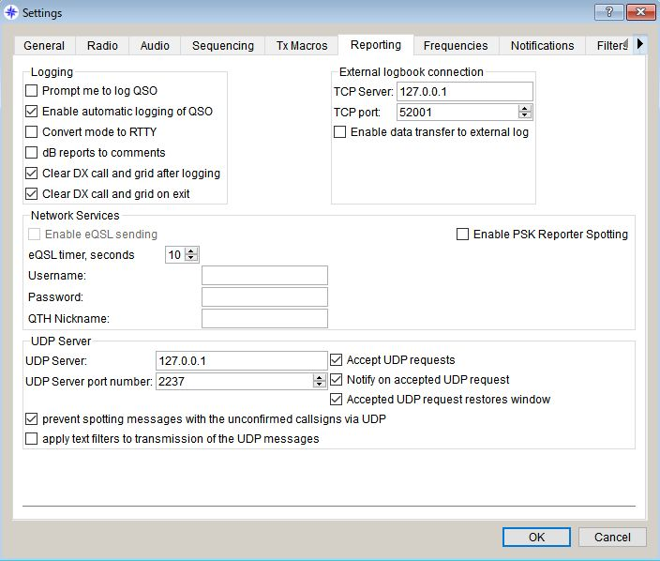

UBM_2

## 3.0. LOGGER32 SETTINGS

The callsign highlight colors and DXCC award tracking information are displayed in UDP Bandmap depend on the settings in "DX Spot highlight color" and "Setup phone/digital modes"

Settings for me to operate FT4, FT8, JT9 and JT65 below.

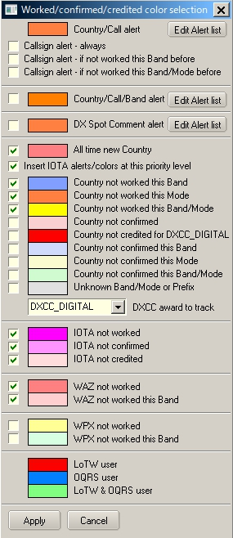

UBM_3

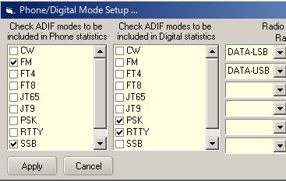

UBM_4

With this settings Worked/confirmed Window looks like below.

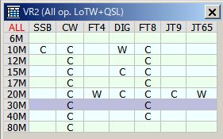

UBM_4A

## 4. OPERATION (1)

* + Run WSJT-X or JTDX. Do not run JTAlert at same time.
  + Run Logger32
  + Right click on "UDP" in the lower status bar. Click "Open UDP Bandmap"

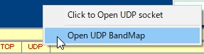

UBM_5

When WSJT-X or JTDX decode callsigns these callsigns are displayed in the UDP Bandmap.

WSJT-X or JTDX, Band and Mode are displayed in title bar. Band and Mode are derived from WSJT-X or JTDX.

* + Click " "X" to close UDP Bandmap.

It is more convenient to run/close WSJT-X or JTDX from “Start”/”Stop” in the menu. See paragraph 5.4 Start.

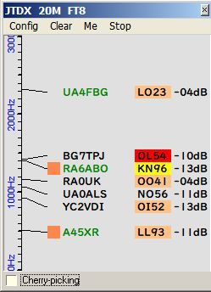

UBM_6

### Logging QSO

When QSO is logged in JTDX/WSJT-X this QSO is logged directly in Logger32. You should notice the difference between JTDX and WSJT-X.

If you use JTDX you need no mouse clicking. QSO is logged automatically in Logger32.

If you use WSJT-X you need to click “OK” in the WSJT-X logging window in order to log QSO in WSJT-X and Logger32.

“OK” and “Cancel” button appears here and there.

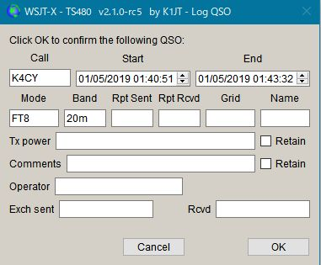

UBM_6AC1

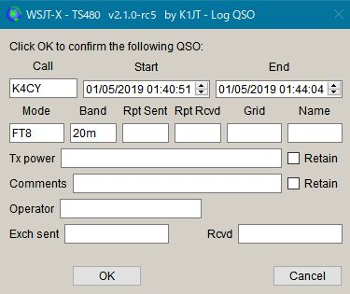

UBM_6AC2

The UDP Logging requests.txt file logs every QSO logging request received from the WSJT/JTDX UDP.  This file is created in the \Logger32 directory and erased every time Logger32 starts.



UBM_6AC3

The VFO frequency plus receive tone frequency are written in the ADIF FREQ_RX field in the Logbook. Logger32 calculates and logs the ADIF DISTANCE field. Look at logged QSO with below. Gridsquare and Distance are logged only if they there are decoded.

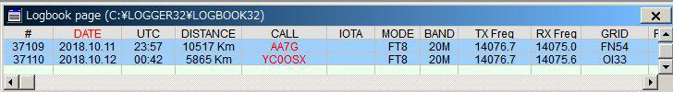

UBM_6AC4

## 5.0 MENU

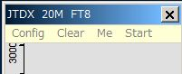

UBM_6A

## 5.1 Config

Select the Config menu item.

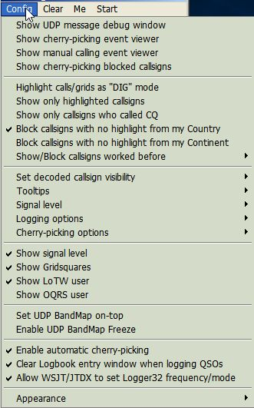

UBM_6AB

There are a lots of options. You may choose whatever you prefer now.

If you want to see highlight colors and tooltips information based on every mode then un-check "Highlight callsigns as "DIG" mode" This option works for displaying "QSOd B4" mark as well.

If you want to set the Logger32 frequency/mode from WSJT-X/JTDX then check “Allow WSJT/JTDX to set frequency/mode” Logger32 radio port must be closed. See paragraph 5.4 Start for related explanation and paragraph 5.0 Band Mode Selection Setup in the Logbook Emtry topic.

If you want to see the Gridsquare then check "Show Gridsquares".

### Sub menu for Logging options



UBM_6AC

The UDP Logging requests.txt file logs every QSO logging request received from the WSJT/JTDX UDP. This file is created in the \Logger32 directory and erased every time Logger32 starts.



UBM_6AD

If you want to use direct logging then check “Allow automatic WSJT/JTDX QSO logging”. When “WSJT-X Automatic logging (no mouse clicks)” is enabled, this will automagically close the insanely annoying WSJT-X logging window. The first time you are prompted after starting WSJT-X, Logger32 will close it for you in under 5 seconds (you can close it manually if you like). After that, Logger32 will close in less than 500ms.

The VFO frequency plus receive tone frequency are written in the ADIF FREQ_RX field in the Logbook. Logger32 calculates and logs the ADIF DISTANCE field. Look at logged QSO with below. Gridsquare and Distance are logged only if there are decoded.

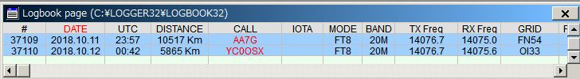

UBM_6B

When “Log additional info from Logbook Entry Window” is checked, the following data entered into the Logbook Entry Window is logged with the UDP logging information if not already in the UDP logging message.

TX_PWR, QTH, ADDRESS, COMMENT, NAME, STATE, and CNTY.

If you want to set the Logger32 frequency/mode from WSJT-X/JTDX then check “Allow WSJT/JTDX to set frequency/mode” Logger32 radio port must be closed. See paragraph 5.4 Start for related explanation and paragraph 5.0 Band Mode Selection Setup in the Logbook Entry Window section.

### Sub menu for Signal level

If you want to see the signal level then check "Show signal level" and click ”Signal level” to select the signal level type, SNR or S units.

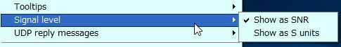

UBM_6C

If you want to see the Gridsquare then check "Show Gridsquares".

### Sub menu for “Show/Block callsigns worked before”

If you want to block callsigns QSOd this band/mode B4 then check like this.

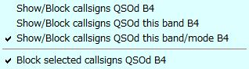

UBM_6D

## Sub menu for "Set decoded callsign visibility"

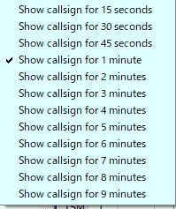

UBM_8

## Sub menu for "Tooltips"



UBM_9

## Sub menu for "Cherry-picking options"

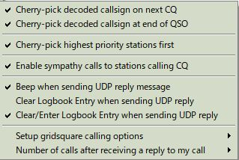

New UBM_9A ~~UB9_A~~

Click “Setup gridsquare calling options” to setup gridauare calling options and ckick “Number of calls after receiving a reply to my call” to setup the number.

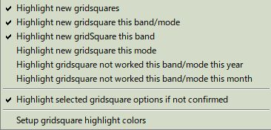

UBM_9A1

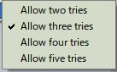

UBM_9A2

## Sub menu for "Appearance"

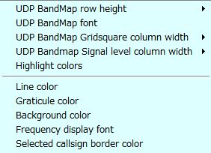

UBM_10

UDP Bandmap Gridsquare and Signal Level column width can be selected respectively.

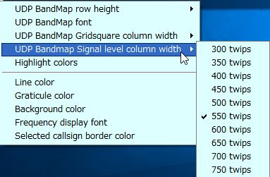

UBM_10A

Click "Highlight colors" to configure Gridsquare highlight colors and UDP Bandmap text color. If you prefer to see bold text for callsign who have called CQ then check "Show bold text who have called CQ"

. 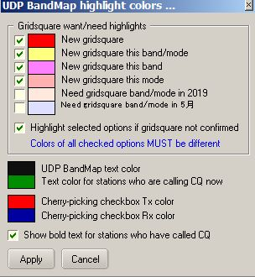

UBM_11

Sample below.　The stations who are calling CQ now are displayed in Green text, the stations who have called CQ are displayed in Black/bold text and the stations who are working other stations are displayed in Black text.

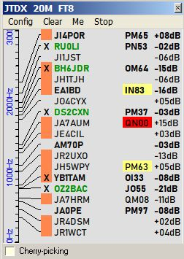

UBM_11A

## 5.2. Clear

This clears UDP Bandmap.

## 5.3. Me

This opens the Calling Me UDP Bandmap and hide this item in the menu bar. See details in paragraph [Operation(4)](#8.0._OPERATION(4)).

## 5.4. Start

Default item is WSJT-X and/or JTDX if these programs are installed in your PC. You may add another shortcut using unique radio name. See details in WSJT-X/JTDX Help.

If you start WSJT/JTDX from Start menu, the Logger32 radio serial port is closed before the digital application starts. WSJT-X/JTDX caption is replaced by shortcut caption + “& Logger32”and “X”is hidden in the title bar.



UBM_11AB

Then if you close the digital application from Logger32 (either by UN-checking the START menu, or by closing the UDP Bandmap), the Radio serial port is automatically reopened.

If the Logbook Entry Window stays populated, Logger32 makes the Radio be aligned with the Logbook Entry Window (spotted) information.

If the Logbook Entry Window is empty/wiped, Logger32 sets the Radio to pre-WSJT-X/JTDX opening state.

If you click WSJT-X, WSJT-X starts, then if you click JTDX, WSJT-X close and JTDX starts.

If WSJT-X/JTDX opens with Radio in split mode then Radio turns in split off mode. You need to add $SplitVisualAlertsOff$$clearlog$ as “before starting WSJT/JTDX” macro.

**Note: DO NOT TRY TO RUN WSJT-X/JTDX IN XP COMPATIBLE MODE, OTHERWISE IT DOES NOT WORK CORRECTLY.**

## 

UBM_11B

Click “Setup shortcuts” to add/edit shortcut and put commands/macros for Radio 1/2 if you like to execute before starting WSJT-X/JTDX and after closing WSJT-X/JTDX.　Macros for Radio Control Panel can be used in this table as well.

Example macros below are Split OFF, Power 50W, NB OFF/ NR OFF (Radio2-IC7300) for before starting WSJT-X/JTDX and Power 100W for after closing WSJT-X/JTDX.

## 

UBM_11C

## 6.0 OPERATION (2)

If you move mouse over callsign then tooltips appears.

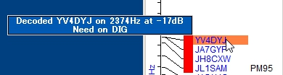

UBM_12

If you left-click any callsign then this callsign is transferred in Logbook Entry Window.

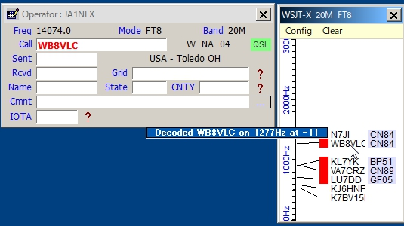

UBM_13

If you right-click any callsign then history of this callsign is displayed. (max 15 messages)

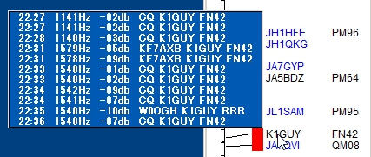

UBM_14

If you configure various options properly then you see LoTW/OQRS user, QSO B4, highlighted callsign and Gridsquare.

When QSO is logged in WSJT-X/JTDX then Logger32 log this QSO via UDP if "Allow QSO automatic logging" is checked.

## 7.0 OPERATION (3)

Logger32 can send reply message to JTDX or WSJT-X When it receives reply message then it will transmit message corresponding to the reply message.

For JTDX following options should be checked and “AutoTX” should be turned ON.

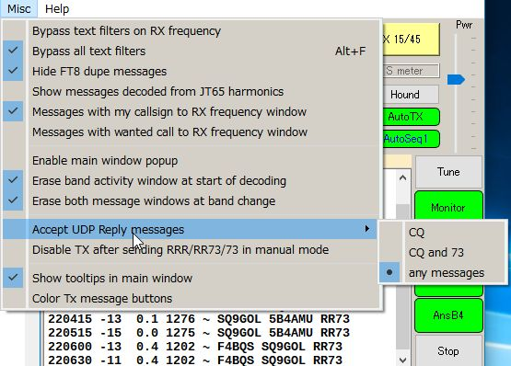

UBM_14A

For WSJT-X Auto Seq should be checked and “Call 1st” should be unchecked.

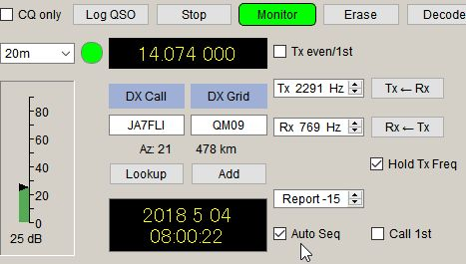

UBM_14B

The following options should be checked in the UDP Bandmap Config menu. Uncheck “Call selected callsign at end of QSO” if WSJT-X is used.

## 

UBM_14C

## Manual Calling

Click on any callsign you want to call. The callsign is surrounded by a box and transferred to the Logbook Entry Window. The box border color can be configured in “Config”, “Appearance”, “Selected callsign border color”.

## 

UBM_14D

When:

* + (a) The operator calls CQ on the next time slot, a reply message is sent to JTDX or WSJT-X and it will transmit a message calling him/her.
  + (b) The operator sends a message with 73 or RR73 or RRR, a reply message is sent to JTDX and it will transmit message calling him/her.
  + (c) If the operator replies to you then the box disappears.
  + (d) If the operator dose not reply to you then it tries max 5 calling cycles and the call is canceled.
  + (e) If there is nothing heard from the station for 90 seconds then the call is cancelled.

**Note**: For WSJT-X users, do not use this feature, otherwise you have unexpected result.

The Logbook Entry Window is cleared.

To show the manual calling process click “Show manual calling event viewer” in Config menu.

## 8.0. OPERATION(4)

## Cherry-Picking

Logger32 can send reply message to JTDX or WSJT-X for automatically selected callsign. When JTDX or WSJT-X receives reply message then it will transmit message corresponding to the reply message.

**Note:** JTDX allows reply message for CQ/73/RR73, however WSJT-X allows reply message only for CQ.

**Note:**

a)  It does not work duplicate QSOs on a Band/Mode

b)  It does recognize CQ, CQ DX, and CQ <your Continent>. All others are ignored.

c)  It does call DXCC highlighted callsigns (based on user configuration options in DX spot highlight color　table.

d) It does call stations with highlighted Gridsquares.(based on user configuration options in UDP Bandmap highlight color table).It picks highlighted callsigns or stations with highlighted Gridsquares with the following priority:

Priority in DX spot color table → Grid highlight color table → CQ  
(Highest-left to lowest-right)

There is a menu on the UDP Bandmap under CONFIG | CHERRY-PICKING OPTIONS.  If the option CHERRY-PICK HIGHEST PRIORITY CALLSIGN FIRST is checked, then after each decode period, Logger32 chooses the highest priority station and calls it (cherry-pick only the ripest cherry).  If the option is not checked the Logger32 calls the first cherry it sees.

e) It remembers the callsign of a station that drops his callsign in the middle of a QSO.  On completion of the current QSO (or attempted QSO), Logger32 automatically replies to the station that called.

To enable Cherry-picking, click “Config” then check “Enable automatic cherry-picking” Status bar appears at bottom in UDP Bandmap. Check “Cherry-picking” Check/Uncheck this option to turn Cherry-picking ON/OFF.

When Cherry-picking pick callsign, the callsign is displayed in status bar in Red color. When he send CQ/73/RR73 JTDX will call him automatically.

After 90 seconds Cherry-picking for the callsign ends and the callsign disppears.

“Enable sympathy calls” option (see UBM_14C). If this option is checked it calls any CQ caller at random even if he is not highlighted. The tooltip for the cherry-picked callsign is displayed like this.

## 

UBM_14DA1

To show cherry-picking process click “Show cherry-picking event viewer” in Config menu.

## Cherry-picking blocked callsign

“Show cherry-picking blocked callsigns” option.

If you right-click on the area where cherry-picked callsign is displayed then you see another menu.

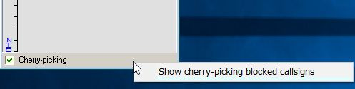

UBM_14DA2

Click “Show cherry-picking blocked callsigns” to show the table. Click “Wide” button.

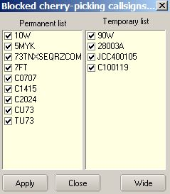

UBM_14DA3

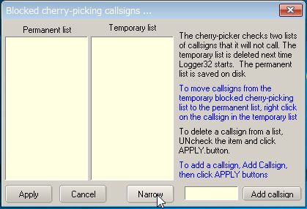

UBM_14DA4

Wildcard can be used as blocking callsign.

See the text above. It explains how to add callsign you want to block and how it works.

Drag mode:

You can now drag & drop callsigns from the UDP Bandmap into the cherry-picking blocking window. If not already open, the cherry-picking window will automatically open, once you start to drag a callsign.

You will notice the APPLY button is no longer visible unless the user wishes to make changes by UNchecking callsigns and clicking APPLY.

Drag & drop changes are made automatically.  Moving a callsign from temporary to permanent makes changes automatically.

If the UDP Bandmap receives text like JCC10010 73 The UDP Bandmap will block the call and also add it to the list of temporary blocked calls.

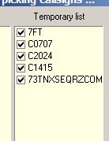

UBM_14DA5

**Note:** Right-click on “Cherry-picking” to show menu. If you prefer then check this option.

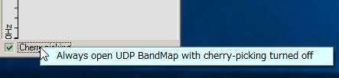

UBM_14DAB

Click “Me” in the Menu to show the Calling Me Bandmap. Only callsigns calling me are displayed in this window.

## 

UBM_14E

**For JTDX:**

It may be a little complicated because JTDX has various options for Auto Seq.　It is better to use following setup to use this functionality.

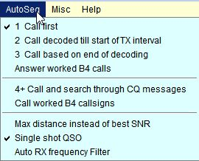m

UBM_14F

When you call CQ and receive multiple replies, these callsigns are displayed in Calling Me Bandmap. JTDX will transmit message automatically for the first decoded callsign. When you finish this QSO, click another callsign. JTDX will transmit message for this callsign.

**For WSJT-X:**

Set options like pic UBM_14B. When you call CQ and receive a reply, callsigns are displayed in the Calling Me Bandmap. Click any callsign you want to answer. WSJT-X will transmit a message for this callsign.

If you move the mouse over a callsign then a tooltip appears.

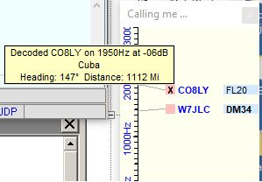

UBM_14G

## 9.0 RPTR (WSJT/JTDX UDP message repeater)

For those who want eye candy programs to monitor UDP messages, but can't get them to work because Logger32 is using port 2237, then right click RPTR at the right of the lower status bar.  Click Setup WSJT/JTDX UDP repeater. Check Enable SEND A, set the port number to 2238, and click APPLY.

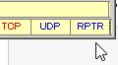

UBM_14H

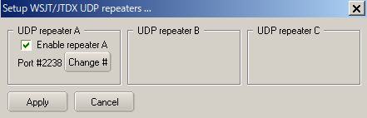

UBM_14I

If you want to use GridTracker (by N0TLL) then follow the steps below:

Run GridTracker and click Setup icon. The default Port for Receive UDP Message is 2237.

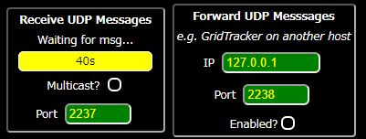

UBM_14I1

Type 2238 for the port of Receive UDP Message and 2239 for the port of Forward UDP Message . These changes are saved in GridTracker. ~~Backlight color is changed to Red. (This change is not saved. Every time you run GridTracker it shows default 2237)~~

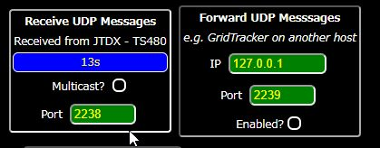

New UBM_14J

If you want to use default UDP port 2237 in GridTracker then you can change UDP port in Logger32 and WSJT-X/JTDX.

In the case of Logger32:

(a) right click RPTR at the right of the lower status bar.  Click Setup WSJT/JTDX UDP repeater. Check Enable SEND A, set the port number to 2237, and click APPLY.

(b) right click on UDP in the lower status bar, click Change WSJT/JTDX port #, type 2238 and click OK. You must change UDP port to 2238 as well in WSJT-X/JTDX.

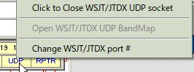

UBM_14K

If you want to use UDPdecoder (by JA1NLX) then follow the steps below. UDPdecoder receives UDP message from JTDX/WSJT-X via RPTR and display UDP message, DT distribution graph, S/N process graph for specific callsign and lowest S/N.

Run Logger32.  
Run JTDX/WSJT-X  
Open RPTR (see UBM_14H and UBM_14I)  
Run UDPdecoder. Set UDP port # (Default is 2238)

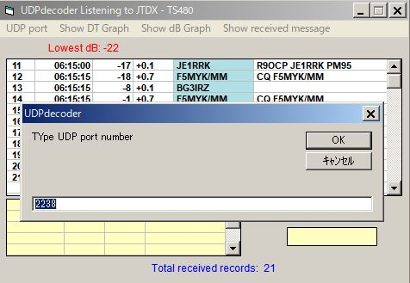

UBM_14L

**10.0. TIPS**

If you have "Show only callsigns calling CQ" and "Show only highlighted callsigns" checked then the only station that are highlighted and calling CQ will show.

The BLOCK COUNTRY and BLOCK CONTINENT options look for a Country/Continent match with the Logger32 Current Operator.  If you have the Logger32 operator set to "At the Beach" or "Club Station" or something other than the callsign of where you are operation, the results will be unpredictable.

Try to change settings of "DX Spot highlight colors" in DX Spot Window and settings of "Setup phone/digital modes" in Tools menu. It affects the way to display highlight colors and tooltips in UDP Bandmap.

## UDP message debug window

This Debug window is very useful to check problem. Click "Show debug window" in Config menu to show debug window. The Reply message is displayed in Red text.

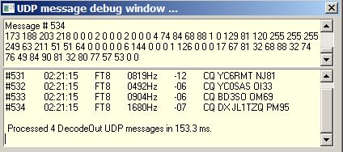

UBM_15

## Cherry-picking event viewer

The cherry-picking event viewer shows all steps regarding cherry-picking. You may understand what is happening now. It shows the number of callsigns decoded this cycle at the bottom right hand corner.

## 

UBM_16

## Manual calling event viewer

The manual calling event viewer shows all steps regarding manual calling. You may understand what is happening now.

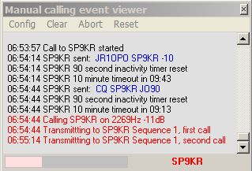

UBM_17

## UDP port settings to use Logger32, JTDX and GridTracker

This is recommended settings to use Logger32, JTDX and GridTracker. IP address and Port # can be changed if needed, however it should be always same for each UDP port respectively.

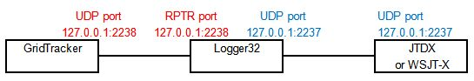

UBM_18